**Data Setup:**

Reliability test and improvement of a sensor system for object detection

Information Technology

Modules Autonomous Intelligent Systems and Machine Learning

By Dr. Peter Nauth & Dr. Andreas Pech

|  |  |
| --- | --- |
| Deblina Karmakar  1427365 | Indranil Saha  1427190 |
| deblina.karmakar@stud.fra-uas.de | indranil.saha@stud.fra-uas.de |

1. Data Collection

1.1 Hard Surface Measurements

We measured for hard surfaces at two distances: 1 meter (m) and 50 centimetres (cm). The measurements were taken to assess. For each distance, we obtained 1000 measurements.

**Distance**:

1 meter (m)

50 centimetres (cm)

**Number of Measurements**:

1000 readings for each distance

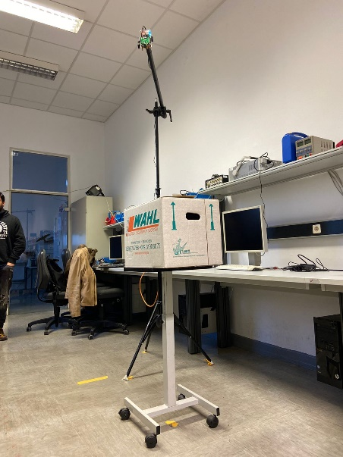

1.2 Soft Surface (Person) Measurements

Similar measurements were taken on soft surfaces to take the readings. The following details outline the data collection process:

Number of Measurements:

1000 readings

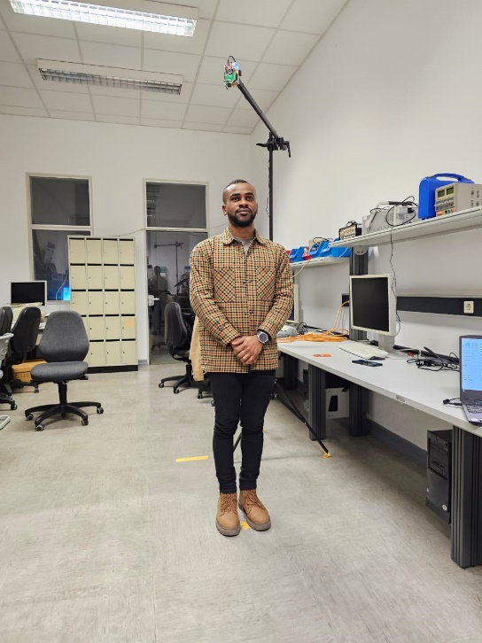

|  |
| --- |
| 1. **FIUS inbuilt distance measurement (dFIUS):** |

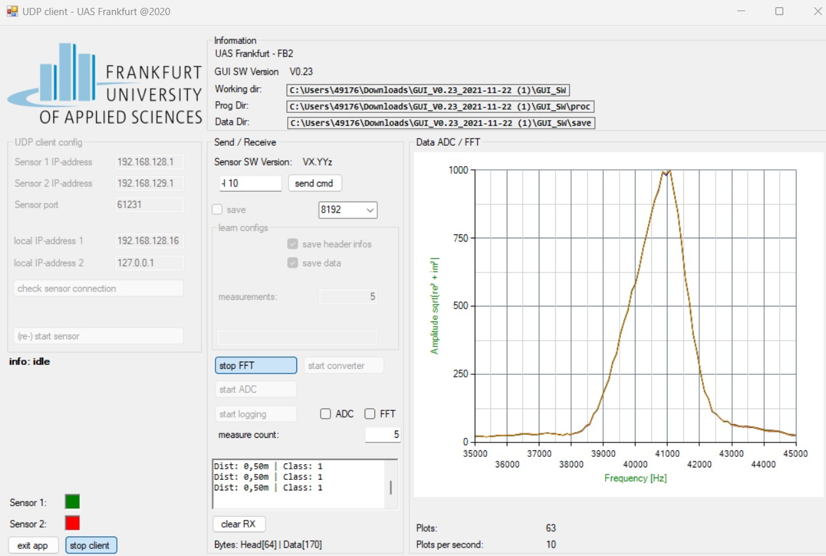

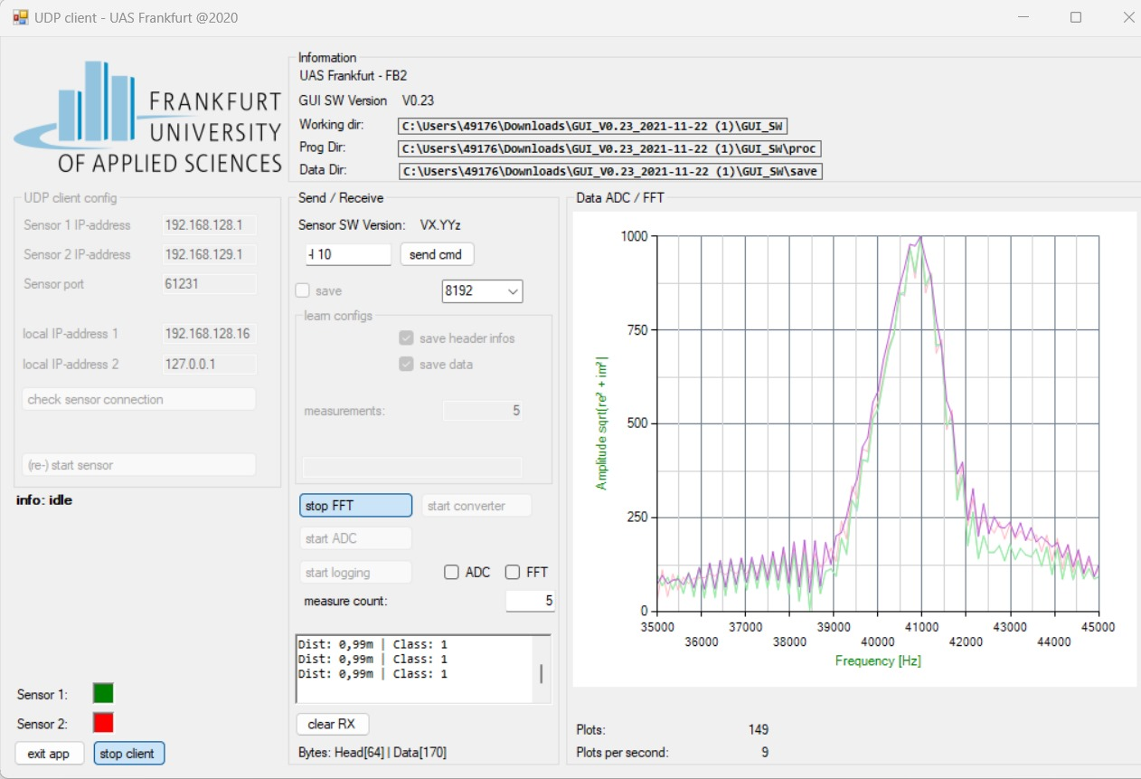

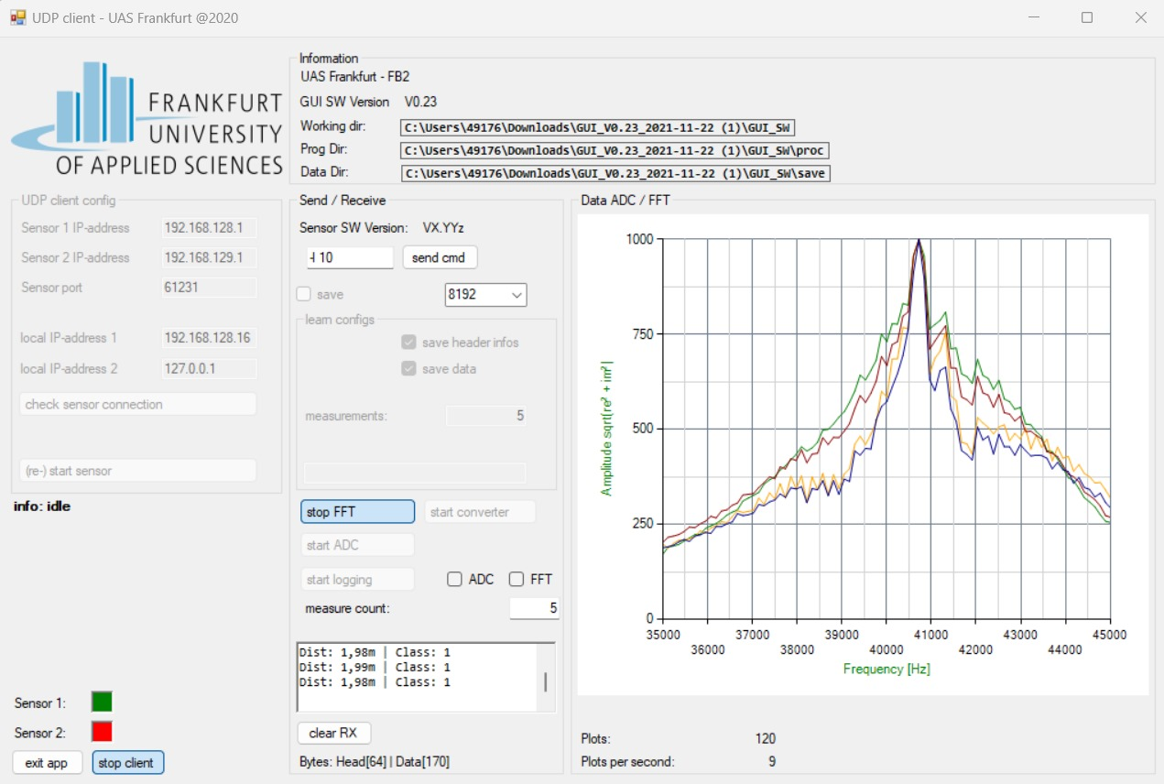

|  |
| --- |
| 1. **2. Manually measured distance using a folding meter stick (dMAN):** |

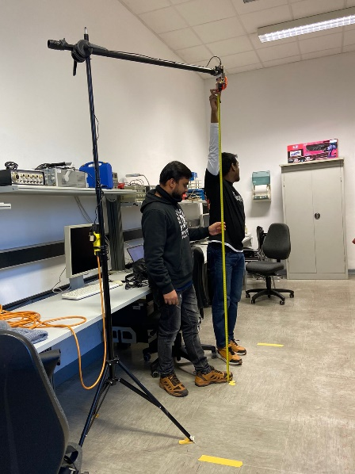 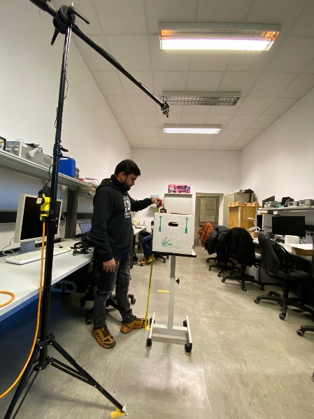

**Comparison**:

|  |  |
| --- | --- |
| **dFIUS** | **dMAN** |
| 1m | 0.99m |
| 50cm | 0.50m |

**Python program that automatically calculates and displays the distance dML between the sensor and the first reflection using the ML first echo detection algorithm given using the Source code.**

**Approach I:**

import smbus

import time

import numpy as np

from scipy.signal import find_peaks

# Constants

I2C_ADDRESS = 0x70

V_SONIC_WAVE = 343.2 # Speed of sound in m/s

ADC_START_DELAY_US = int(0.30 * 2 * 1e6 / V_SONIC_WAVE)

ADC_BUFFER_DELAY_US = int((16_384 * 512) / 1e3) # Assuming ADC_BUFFER_SIZE is 16384

ADC_MID_US = ADC_START_DELAY_US + (ADC_BUFFER_DELAY_US // 2)

# Setup I2C

bus = smbus.SMBus(1) # Typically 1 for /dev/i2c-1

def start_ultrasonic():

# Write to I2C to start ultrasonic measurement

bus.write_byte_data(I2C_ADDRESS, 0, 0x52) # 0x52 is a placeholder command

def read_ultrasonic():

# Read from I2C

high_byte = bus.read_byte_data(I2C_ADDRESS, 1)

low_byte = bus.read_byte_data(I2C_ADDRESS, 2)

time_of_flight_us = (high_byte << 8) | low_byte

return time_of_flight_us

def get_adc_data():

# Placeholder for actual ADC data acquisition

# Replace with actual ADC reading code

return np.random.randn(16_384) # Random data to simulate ADC data

def calculate_distance(time_of_flight_us):

return V_SONIC_WAVE * (time_of_flight_us / 2e6)

def measure_distance():

start_ultrasonic()

time.sleep(ADC_START_DELAY_US / 1e6) # Convert microseconds to seconds

adc_data = get_adc_data()

time.sleep(ADC_BUFFER_DELAY_US / 1e6) # Wait for ADC buffer to fill

time_of_flight_us = read_ultrasonic()

distance = calculate_distance(time_of_flight_us)

return distance

# Example usage

if __name__ == '__main__':

distance = measure_distance()

print(f"Measured distance: {distance} meters")

**Approach II:**

import numpy as np

import matplotlib.pyplot as plt

from redpitaya.overlay.mercury import mercury as overlay

def ml_first_echo_detection(signal, sampling_rate):

# ML first echo detection algorithm

threshold = 0.5 # Adjust threshold based on your specific use case

peaks, _ = find_peaks(signal, height=threshold)

if len(peaks) > 0:

return peaks[0] / sampling_rate

else:

return None

def main():

# Initialize Red Pitaya overlay

ol = overlay()

rp = ol.red_pitaya

# Parameters

sampling_rate = int(rp.fpga.api.osc_frequencies_get(0))

# Configure and acquire data from channel 1 (assuming ultrasonic sensor is connected to channel 1)

rp.reset()

rp.waveform_acquisition_start()

rp.waveform_acquisition_trigger()

# Wait for acquisition to complete

while rp.waveform_acquisition_completed() == 0:

pass

# Retrieve acquired data

data = rp.waveform_acquisition_data(0, -1)

# Apply ML first echo detection algorithm

detected_distance = ml_first_echo_detection(data, sampling_rate)

# Display results

if detected_distance is not None:

print(f"ML First Echo Detected at a distance of {detected_distance:.4f} meters.")

else:

print("No echo detected.")

# Plot the acquired data

plt.plot(data)

plt.title('Acquired Ultrasonic Signal')

plt.xlabel('Time (samples)')

plt.ylabel('Amplitude')

plt.show()

if _name_ == "_main_":

main()